Victor Nguyen

Professor Hadaegh

CS 443

2 March 2020

Assignment 1

**Question 1**

A) **Write the tables**

Product (ProductID, ProductDescription)

Item (ItemNum, ItemDescription)

Receipt (ReceiptNum, SalesDate)

Used (ProductID*, ItemNum*, QuantityUsed)

Sold (ProductID*, ReceiptNum*, QuantitySold)

B) **Place the tables in 3rd normal form (if necessary)**

The initial table that was given in the problem had transitive dependencies but the initial table is able to branch off into 5 tables like in question 1A. The 5 tables the initial table created are Product, Item, Receipt, Used, and Sold.

C) **Create ERD based on the normalized tables**

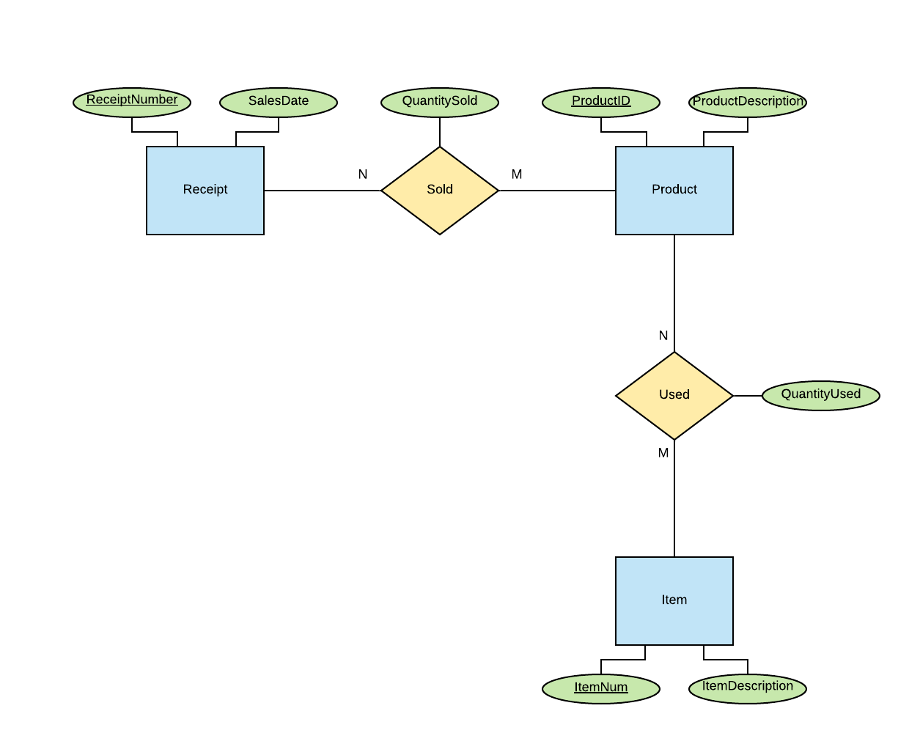

D) **Write a script to create a database. Your script should create the tables and ensures that all constraints are set properly.**

DROP TABLE Product;

DROP TABLE Item;

DROP TABLE Receipt;

DROP TABLE Used;

DROP TABLE Sold;

CREATE TABLE Product (

ProductID NUMBER,

ProductDescription VARCHAR2(200),

CONSTRAINT Product_PriKey PRIMARY KEY(ProductID)

);

CREATE TABLE Item (

ItemNum NUMBER,

ItemDescription VARCHAR2(200),

CONSTRAINT Item_PriKey PRIMARY KEY(ItemNum)

);

CREATE TABLE Receipt (

ReceiptNumber NUMBER,

SalesDate DATE,

CONSTRAINT Receipt_PriKey PRIMARY KEY(ReceiptNumber)

);

CREATE TABLE Used (

ProductID NUMBER,

ItemNum NUMBER,

QuantityUsed NUMBER,

CONSTRAINT Used_PriKkey PRIMARY KEY(ProductID, ItemNum),

CONSTRAINT Used_ForKey1 FOREIGN KEY(ProductID) REFERENCES Product(ProductID),

CONSTRAINT Used_ForoKey2 FOREIGN KEY(ItemNum) REFERENCES Item(ItemNum),

CONSTRAINT QuantityUsed_Check CHECK(QuantityUsed >= 0)

);

CREATE TABLE Sold (

ProductID NUMBER,

ReceiptNumber NUMBER,

QuantitySold NUMBER,

CONSTRAINT Sold_PriKkey PRIMARY KEY(ProductID, ReceiptNumber),

CONSTRAINT Sold_ForKey1 FOREIGN KEY(ProductID) REFERENCES Product(ProductID),

CONSTRAINT Sold_ForKey2 FOREIGN KEY(ReceiptNumber) REFERENCES Receipt(ReceiptNumber),

CONSTRAINT QuantitySold_Check CHECK(QuantitySold >= 0)

);

**Question 2**

A) **Change the ERD to tables**

Physician (PhysID, PhyName, PhysDept, DeptSupervisorId, TreatCost, TreatDesc, TreatId)

Patient (PatientID, PhysID*, PatientName, PatientAddress, AdminDate, HospitalStaydays, RoomPhone, RoomNo, RoomRate, AmountOwing)

B) **Place the tables in 3rd normal form (if necessary)**

Physician (PhysID, PhysName, PhysDept*, TreatID*)

Department (PhysDept, DeptSupervisorID*)

Treatment (TreatID,TreatCost,TreatDesc)

Patient (PatientID, PatientName, PatientAddress, AdminDate, HospitalStaydays, RoomNo*, PhysID*)

Room (RoomNo, RoomPhone, RoomRate)

C) **Revise the given ERD based on the normalized tables (if necessary)**

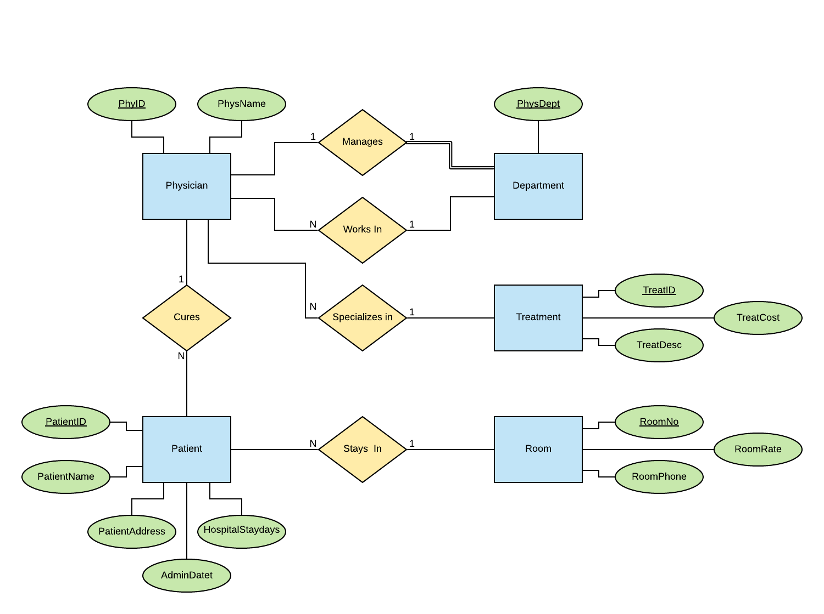

D) **Your script should create the tables and ensures that all constraints are set properly.**

DROP TABLE Physician;

DROP TABLE Department;

DROP TABLE Treatment;

DROP TABLE Patient;

DROP TABLE Room;

CREATE TABLE Physician (

PhysID NUMBER,

PhysName VARCHAR2(50),

PhysDept NUMBER,

TreatID NUMBER,

CONSTRAINT PhysName_Null NOT NULL,

CONSTRAINT Physician_PriKey PRIMARY KEY(PhysID),

CONSTRAINT Physician_ForKey1 FOREIGN KEY(PhysDept) REFERENCES Department(PhysDept),

CONSTRAINT Physician_ForKey2 FOREIGN KEY(TreatID) REFERENCES Treatment(TreatID)

);

CREATE TABLE Department (

PhysDept NUMBER,

DeptSupervisorID NUMBER,

CONSTRAINT Department_PriKey PRIMARY KEY(PhysDept)

);

CREATE TABLE Treatment (

TreatID NUMBER,

TreatCost NUMBER(10, 2),

TreatDesc VARCHAR2(200),

CONSTRAINT Treatment_PriKey PRIMARY KEY(TreatID),

CONSTRAINT TreatCost_Check CHECK(TreatCost >= 50.00)

);

CREATE TABLE Patient (

PatientID NUMBER,

PatientName VARCHAR2(50),

PatientAddress VARCHAR2(200),

AdminDate DATE,

HospitalStayDays NUMBER,

RoomNo NUMBER,

PhysID NUMBER,

CONSTRAINT PatientName_Null NOT NULL,

CONSTRAINT PatientAddress_Null NOT NULL,

CONSTRAINT Patient_PriKey PRIMARY KEY(PatientID),

CONSTRAINT Patient_ForKey1 FOREIGN KEY(RoomNo) REFERENCES Room(RoomNo),

CONSTRAINT Patient_ForKey2 FOREIGN KEY(PhysID) REFERENCES Physician(PhysID),

CONSTRAINT HospitalStayDays_Check CHECK(HospitalStayDays >= 0)

);

CREATE TABLE Room (

RoomNo NUMBER,

RoomPhone VARCHAR(8),

RoomRate NUMBER(10, 2),

CONSTRAINT Room_PriKey PRIMARY KEY(RoomNo),

CONSTRAINT RoomRate_Check CHECK(RoomRate >= 30.00 AND RoomRate <= 100.00),

CONSTRAINT RoomNo_Check CHECK(RoomNo >= 100 AND RoomNo <= 999)

);

ALTER TABLE DEPARTMENT

ADD CONSTRAINT Department_ForKey1 FOREIGN KEY(DeptSupervisorID) REFERENCES Physician(PhysID);

**Question 3**

A (A1, A2)

B (B1, B2, A1, C1)

C (C1, C2)

D (D1, D5, D2, D3, D4)

E (E1, (D1*, D5*), E2, AttOfR5)

F (F1, F2, F3, F4, (E1*, D1*, D5*), AttOfR5)

R3 (C1*, (D1*, D5*), AttOfR3)

**Question 4**

Bank (Code, Name, Addr)

Bank-Branch (BranchNo, Code*, Addr)

Account (AcctNo, Balance, Type, BranchNo*, Code*)

Loan (LoanNo, Account, Type, BranchNo*, Code*)

Customer (SSN, Name, Phone, Addr)

A-C (AcctNo*, SSN*)

L-C (LoanNo*, SSN*)

**Question 5**

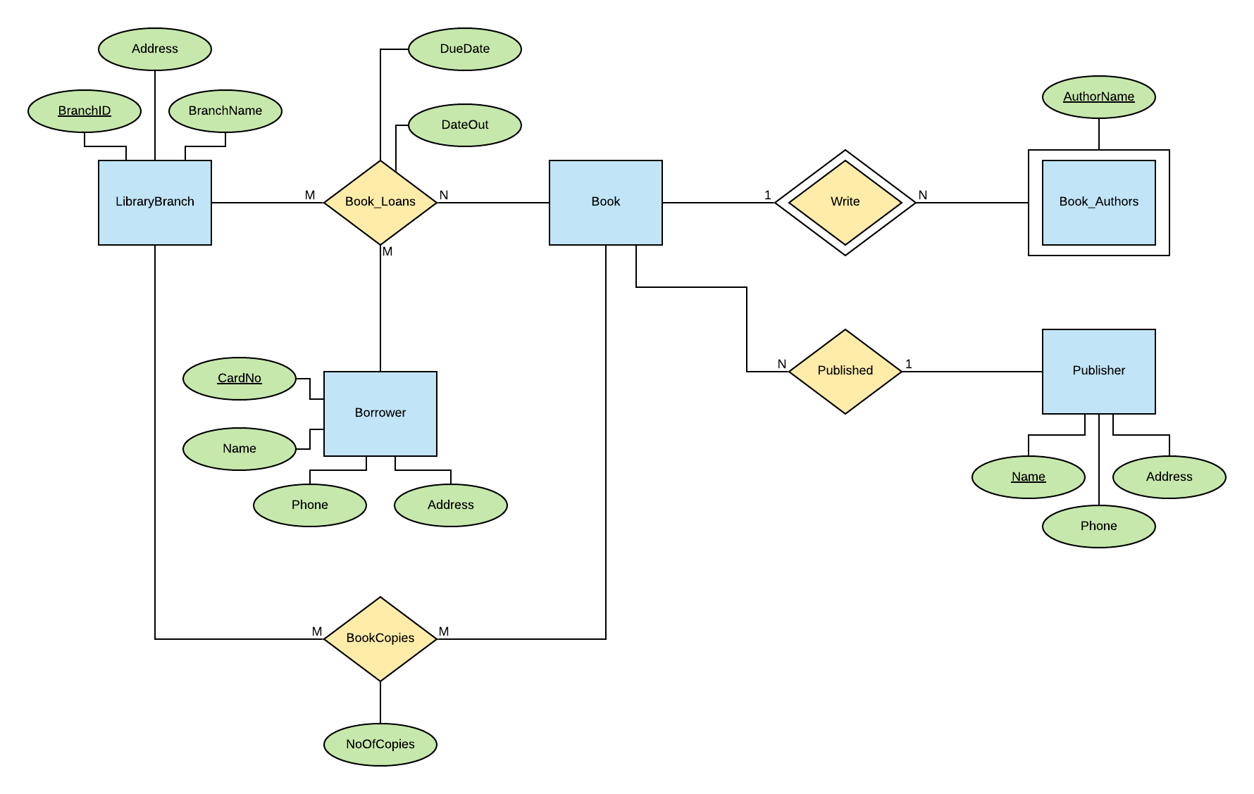

**Question 6**

